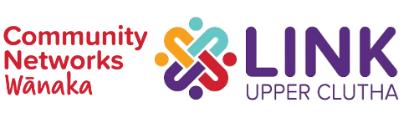
2022 Community Group Support Fund Application
General criteria:
This fund has been established to increase community groups’ impact and enhance their capability, by supporting community initiatives that may not happen without this funding.
Costs must be project or event based (not ongoing operational), can include expenses involved with meetings, educational speakers, training, marketing, materials/collateral, etc. Community groups must be not-for-profit, have an annual budget of under $50,000, and do not require legal entity status. Grants are capped at $2000 (excl GST) per group, and applications are accepted on a rolling basis, with the evaluation panel gathering once a month.
Reporting:
Within one month of the event/project completion, LINK requires a brief report answering the following questions:
- What were the funds used for?
- How many participants benefited?
- What outcomes were achieved (this could be for the participants, your organisation, and/or the community generally)?
- Anything else that helps tell the story?

Application Form
Date of application
Name of applicant
Address
Phone
Email
Name of organisation or group
Legal status (if any)?

Please see questions on page 2-3.

- WHAT? Please briefly describe the project or event for which you are seeking funding. For example, we’d like to know:
- What are you trying to achieve?
- Who will your project or event benefit?
- What are your key expected outcomes for beneficiaries or the community?
- HOW AND WHEN? Outline your plans for the project. For example, we’d like to know:
- What steps will you take to complete your initiative?
- Who will be involved?
- What is your estimated timeline/completion date?
- WHY? Explain why your initiative is important for our community. For example, we’d like to know:
- What problem are you trying to solve or opportunity you are hoping to leverage?
- How have you identified the need for this project/event?
- HOW MUCH? Provide the overall budget – expenses and any revenue – for this project/event.
- What amount are you requesting from this fund ($2000 maximum)?
- How will the money be spent?

Save this form with your group’s name in the filename and email it to kathy@link.org.nz

